**Experiment** **1**:-

Aim:- Design a LED flasher.

Apparatus:-Arduino board,Bread board,Resistor,LED’s,Wires etc.

Circuit diagram:-

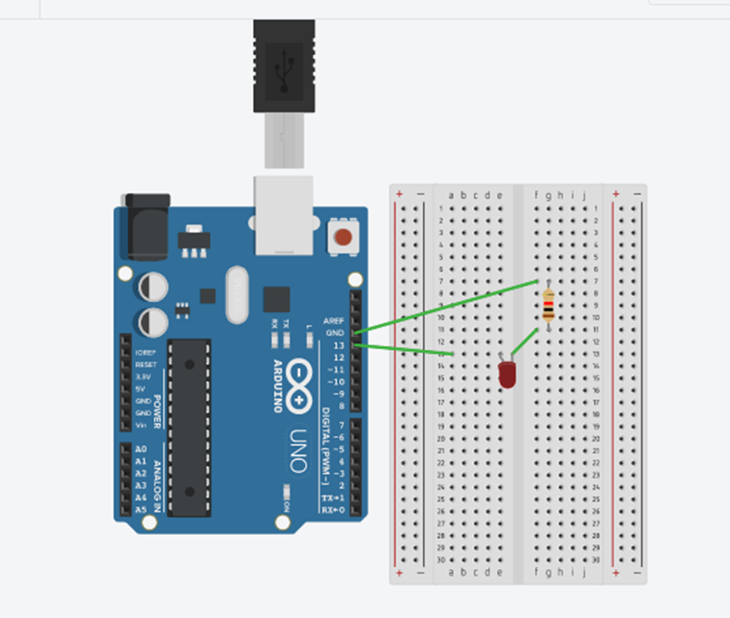

**Theory**:-

Concept used:-

The concept used for this practical are:-

* The LED’s will glow with the help of an arduino board and bread board.
* Using breadboard test the electronic circuits and certain parts of breadboard are joined together so that electricity will pass from it and by which we can make the electric circuits.
* Arduino board is connected to computer via USB. The User will write the code in IDE and by using the port COM21 uploads it and executes it in arduino app.
* Arduino provides the digital signals with the help of which LED’s will glow accordingly .
* In series circuit voltage gets divided and in parallel circuit current gets divided.
* Ohm’s law:-It states that the current through a conductor is directly proportional to the voltage across the two points provided that the physical conditions such as temperature remains constant .

V=IR

**Learning** **and** **observations**:-

Learning:-

* From this task I have learned how to make the series connection using an arduino board and breadboard to make the LED’s glow.
* By this practical I have learned how the wires are connected in breadboard with respect to each other and how the breadboard is helpful in making the electric circuits.
* I have gained a practical experience of the electronic circuits and how led’s will glow in reality with the help of hardwares and softwares.
* I have learned more about the arduino board that how arduino works and how current flows through it.

**Observations:-**

* When we pass electrical signals to the arduino board the LED’s will glow and they will switched off accordingly.

**Learning outcomes:-**

* By doing this experiment I have learned how to make the electric circuits using various hardwares like by the help of an arduino board and breadboard which is a new device for us to learn and to know more about it.
* By the help of this experiment I have learned how we can glow the LED’s in various patterns by the help of an arduino board by making codes according to our need.
* After doing this experiment I have gained the practical skills in electronics that how to make the circuits using different hardwares and also enhancing my knowledge in coding and have a good work experience.

**Problems and troubleshooting:-**

The problems caused by me while doing this experiment are as follows:-

* The arduino board was not properly working so I detached its wire from the computer and connect it again properly and also selected the required arduino board and arduino port(COM21) in tools menu.
* The LED’s were not working properly so I replaced these with the new ones.
* The circuit was not getting closed because the wires in breadboard were not placed at their appropriate position so I changed the position of the wires according to the series pattern.

**Precautions**:-

The precautions that we need to keep in mind while doing this experiment are as follows:-

* While doing this experiment we have to keep in mind that circuit should be closed.
* The connections should not be loose and pins should ne inserted properly.
* The two pins of the LED should be connected at their appropriate point that is the positive point should be connected with p pin and the negative point should be connected with negative pin.